Supply and demand on Human Resources

Project-2

**Aim:**

Supply and demand on employees analyze in human resources.

**Introduction:**

Employees status checking in human resources by using PowerBI.Finding all employees belongs to

department and who can get marred,they salary,there is manger for observing also

our Database.

**Problem statement:**

🡺This has so problems database with some null points.

🡺married peoples finding for status recheck

🡺Department at different states about salary

🡺here about how many companys all over country.

**Methodology:**

* By using power BI tools in fields.
* Tables are pie,bar,round etc..,
* Filters in department,gender,salary,etc..,
* Easy to understand dashboard

**Analysis:**

Those are based on the power bi desktop to be imporving the dataset in different manner,this are actually cleaning process done in query editor in transforming data.

Over all view on the data finding some mistakes in that dataset. So I just replacing the null point into zeo value at the emp_id’s here the some date functions was miss matching with date funtions so the numbering oreder as some data funtion in date cloumn.

**🡺Visualizations:-**

1. Salary by departments:-

Here this bar graph shows about the salary by department in gender wise(Male/Female).So In productions gave high salary paid to the employees.Number of total employees are 311.

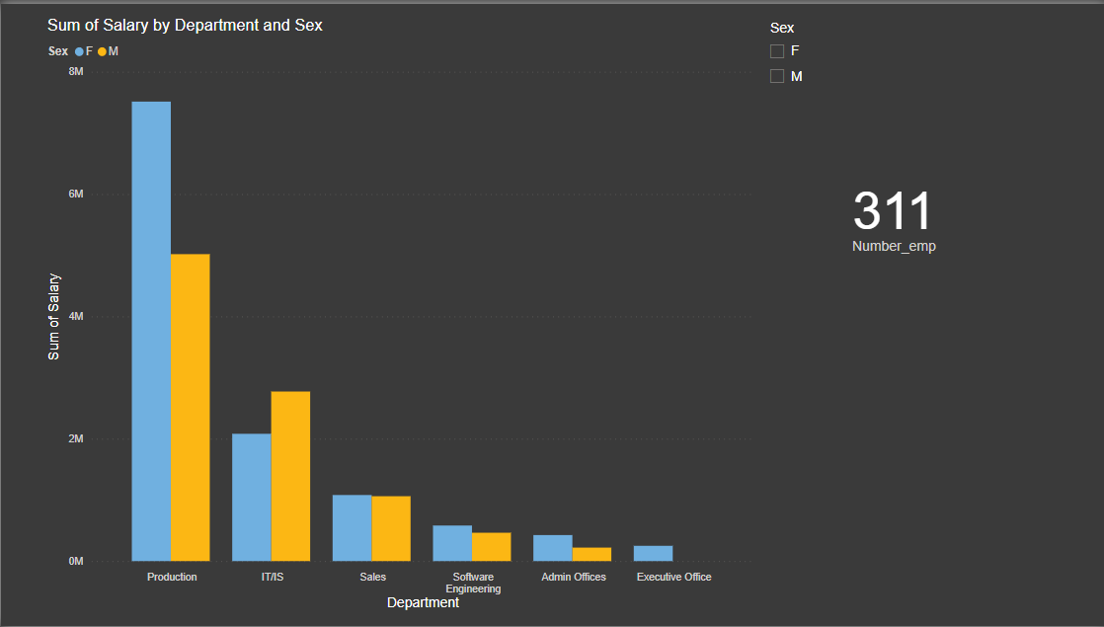

2.**Absence by citizen:**

There is only 3 different type of citizen in the dataset.(us,non us,others)

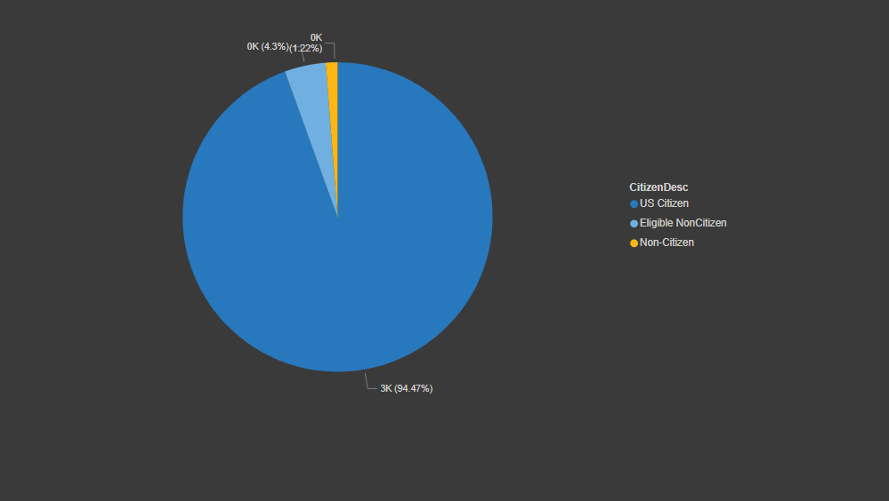

3.**Married gender wise:**

The male and females are married was presented in department as employees.

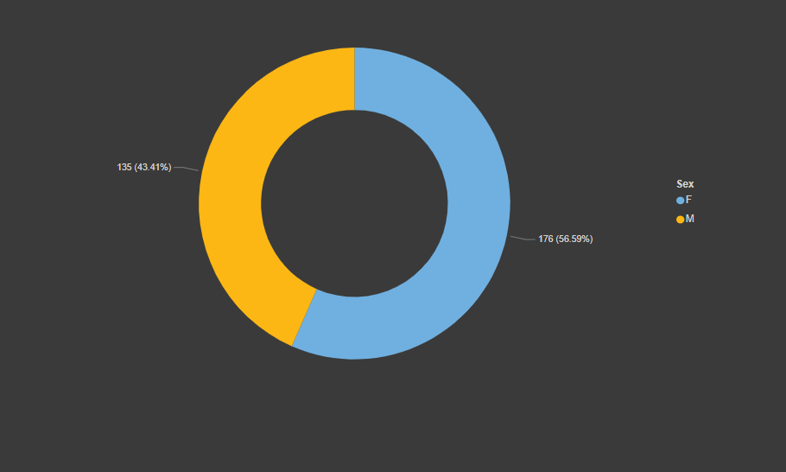

**4.Mangers and department:**

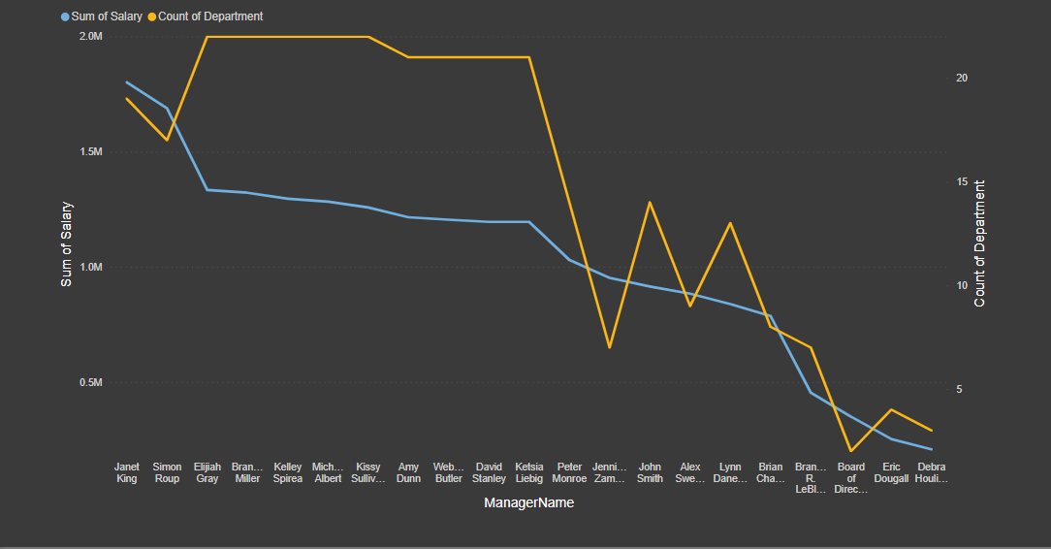

**5.sum of salaries for managers:**

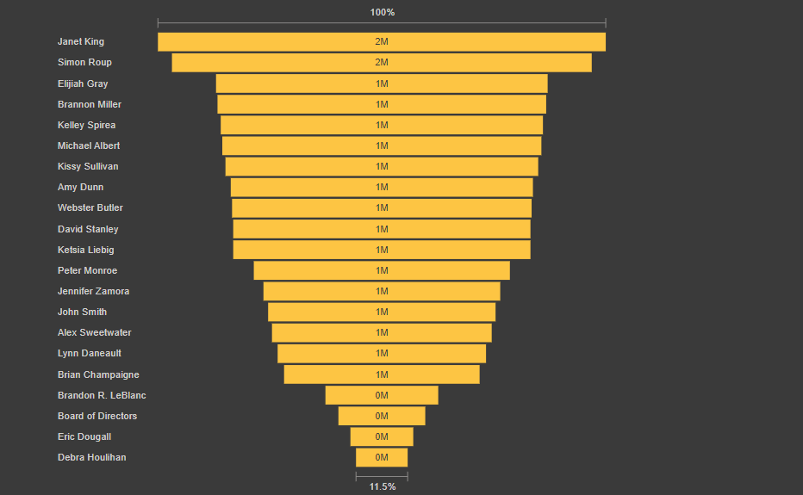

so here it is funnel graph using showing levels of salary like ascending to descending order.

6.**Geographic view:**

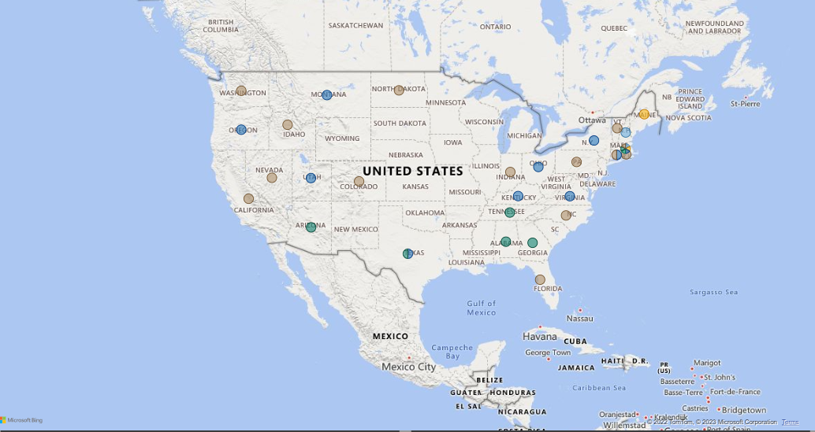

it was showing united states country only the data set only for the us.

**Insight:**

* There are some issues that are present. It is primarily designed as a teaching data set to teach human resources professionals.
* Here is to go with data for analysis empolyee status and cites,salary,sinlge amrried couples,non citizens etc
* This last to gathering data for each and every person at department includes so other employees.
* Date was also from 2016 to 2020 years.

**Recommendation:**

Recent additions to the data include:

Absences

Most Recent Performance Review Date

Employee Engagement Score

Data must be easierr to understanding but some complex values presented.

**Dashboard for this supply and demand on Human Resource**

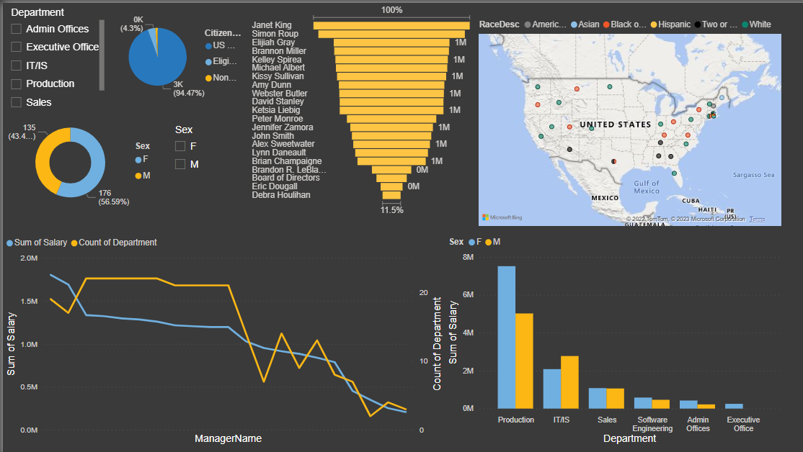

**Conclusion**

This conclusion with sloving the question by using dataset every employee geeting the salary in

Perfect time and this are most human resources. Finding all employees belongs to

department and who can get marred,they salary with help of Power BI tools.